ITEM LIST FOR VICTORIUS ’26 BRING & BUY STALL
Name: |  |  |  | 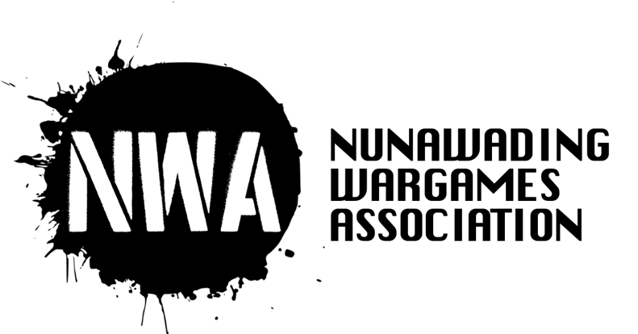
Phone number:
Initials or marking shown on item labels to identify you: |  |  | IGAM
Special instructions:

Item | Description |  |  |  | $ Marked | $ Sold for
1 |  |  |  |  | $ | $
2 |  |  |  |  | $ | $
3 |  |  |  |  | $ | $
4 |  |  |  |  | $ | $
5 |  |  |  |  | $ | $
6 |  |  |  |  | $ | $
7 |  |  |  |  | $ | $
8 |  |  |  |  | $ | $
9 |  |  |  |  | $ | $
10 |  |  |  |  | $ | $
11 |  |  |  |  | $ | $
12 |  |  |  |  | $ | $
13 |  |  |  |  | $ | $
14 |  |  |  |  | $ | $
15 |  |  |  |  | $ | $
16 |  |  |  |  | $ | $
17 |  |  |  |  | $ | $
18 |  |  |  |  | $ | $
19 |  |  |  |  | $ | $
20 |  |  |  |  | $ | $
21 |  |  |  |  | $ | $
22 |  |  |  |  | $ | $
23 |  |  |  |  | $ | $
(More lines for additional items on next page if required) |  |  |  |  | TOTAL (this page): | $

Item | Description |  | $ Marked | $ Sold for
24 |  |  | $ | $
25 |  |  | $ | $
26 |  |  | $ | $
27 |  |  | $ | $
28 |  |  | $ | $
29 |  |  | $ | $
30 |  |  | $ | $
31 |  |  | $ | $
32 |  |  | $ | $
33 |  |  | $ | $
34 |  |  | $ | $
35 |  |  | $ | $
36 |  |  | $ | $
37 |  |  | $ | $
38 |  |  | $ | $
39 |  |  | $ | $
40 |  |  | $ | $
41 |  |  | $ | $
42 |  |  | $ | $
(More lines for additional items on next page if required) |  |  | TOTAL (this page): |  | $
10% commission (rounded to nearest dollar) goes to team running stall |  | 10%: $ | 90%: $

Terms and Conditions:
- We will take 10% commission on items sold on the Bring & Buy.
- We reserve the right to refuse the display and sale of any item from the stand.
- We may refuse to deal with and/or eject any person who we believe may be abusing the spirit of buying or selling at Victorius ‘26.
- Please note that all items placed for sale on the Bring and Buy are left at the seller's sole risk. Nunawading Wargames Association does not accept any responsibility for loss, theft or damage in respect of any items or their sale proceeds.

Name: I Gamer
SIGN ABOVE TO ACKNOWLEDGE YOU HAVE READ, UNDERSTAND AND ACCEPT THESTATEMENTS ABOVE

